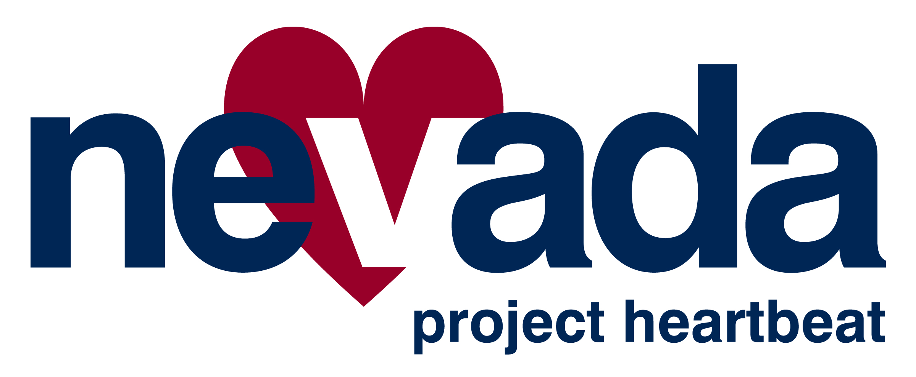

HeartSafe Community
Program

Application

DO YOU LIVE IN A HeartSafe COMMUNITY?

- If someone in your community suffers a sudden cardiac arrest tomorrow, how likely is he or she to survive due to rapid access to life-saving treatment?

- Most cities and towns in Nevada have enhanced 9-1-1. Are emergency operators in your local public safety dispatch able to provide instructions on how to handle an emergency before police, fire or EMS arrives?

- Most cardiac arrests occur outside a hospital. How many residents and public safety officials in your community can recognize the symptoms of cardiac arrest and know how to get help “on the way, right away?” Who knows CPR in your community and is prepared to administer it when necessary?

- Law enforcement officers are proven lifesavers when trained and equipped with automated external defibrillators. Does law enforcement in your community respond to medical emergencies? Are they trained in CPR/AED and equipped with automated external defibrillators?

- Are there medical emergency response plans in place for the schools and municipal buildings in your community? Are AEDs located in these buildings and where? Who has been trained to use the AEDs?

- Early treatment of heart attack improves outcomes. Does your EMS provider have 12-lead EKG capability and are they trained in Advanced Cardiac Life Support?

The answers to these questions could determine whether or not your community qualifies as a Nevada Project Heartbeat HeartSafe Community.

Nevada Project Heartbeat aims to help communities in Nevada improve their health and increase the chance that victims suffering from cardiovascular emergencies will have the best possible chance for survival.

Through the HeartSafe Community program, communities can implement programs to:

- Strengthen what the American Heart Association has called the “Chain of Survival”
- Improve heart health
- Improve chances of survival from Sudden Cardiac Arrest

Chain of Survival – Critical Steps to Take in the Event of Sudden Cardiac Arrest

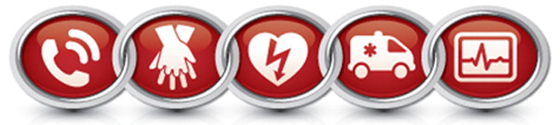

Link One
- Immediate recognition of cardiac arrest and activation of the emergency response system

Link Two
- Early cardiopulmonary resuscitation (CPR) with an emphasis on chest compressions

Link Three
- Rapid defibrillation

Link Four
- Effective advanced life support

Link Five
- Integrated post-cardiac arrest care

American Heart Association. www.heart.org

HeartSafe Community

Designation Letter of Intent

It is the intention of the city/town/community of ______________________ to obtain designation as a Nevada Project Heartbeat HeartSafe Community.

We have chosen _______________________________ as the lead organization to oversee our HeartSafe effort, earning our first 100 heartbeats towards our HeartSafe Community designation.

The coordinator/contact for our HeartSafe Community program will be:

Name: ____________________________________________________________
Address: __________________________________________________________
________________________________________________________
Contact Number: ____________________________________________________
E-Mail: ____________________________________________________________

Our goal is an on-going HeartSafe Community campaign. We want to have the best possible chance for survival for anyone suffering a cardiovascular emergency. This will be possible by raising awareness of the signs and symptoms of a cardiovascular emergency (heart attack, stroke or sudden cardiac arrest); having residents activate the 9-1-1 system for cardiovascular related problems at least 90% of the time in lieu of going to the hospital by a privately owned vehicle; and having the elements of the Chain of Survival in place.

*******************************************
Please return by mail or email to:

Nevada Project Heartbeat
PO Box 9995
Reno, NV 89507
nevadaprojectheartbeat@gmail.com

HeartSafe Community

Designation Application Form

Nevada Project Heartbeat and our partner agencies encourage and promote community awareness regarding heart health and the potential for saving the lives of persons with cardiac emergencies.

In order to increase this awareness, Nevada Project Heartbeat has launched an initiative to designate Nevada cities, towns and communities as HeartSafe Communities.

A HeartSafe Community VIGOROUSLY supports:
- Strategies that improve the chances of favorable outcome for victims of acute event emergencies such as heart attack, stroke, and cardiac arrest.
- Promotion of heart health and early detection.

Designation as a HeartSafe Community is determined by gaining “heartbeats” (points). The number of heartbeats necessary for designation depends on a community’s population.

Please complete all information requested in this application including your community’s population and the total heartbeats from the attached worksheets.

Return completed applications including: heartbeat total, a designation letter of intent, and a letter of explanation for any mandatory criteria your community cannot comply with, to the address below.

Name of City/Town/Community seeking designation:

City/Town/Community

Address

NV
City Zip Code

Chief Elected/Appointed Official (or designee):

Name (Print) Job Title

Business Address Business Phone

NV
City Zip Code

Program Contact Name (Print) Title

Contact Phone Contact Email

Lead Organization for Coordination of HeartSafe Designation (or designee):

Name (Print) Job Title

Business Address Business Phone

NV
City Zip Code

Contact Name (Print) Title

Contact Phone Contact Email

Indicate your community’s population and the total number of heartbeats earned for designation. (See attached worksheets.)

Community Population Total Number of Heartbeats Earned

I attest that all information contained in this application is correct. Supporting documentation is on file for review.

City/Town/Community Official: _________________________________________________ Title

___________________________________ ____________________________________ Name (Print) Signature

Please mail or email this application and worksheets to the addresses listed below:

Nevada Project Heartbeat
PO Box 9995
Reno, NV 89507
nevadaprojectheartbeat@gmail.com

NPH USE ONLY Recommended Not Recommended (Explanation Attached)

Name/Title (Print) Signature

AWARD PRESENTED:
Date Place

HEARTBEAT WORKSHEET

Community Population Category: Please select the appropriate category that most closely conforms to your community’s actual total population. The population size will dictate the number of heartbeats required to be designated as a HeartSafe Community.

I. Up to 5,000 population: Minimum of 700 heartbeats required for designation.
10 HEARTBEATS for each CPR course with at least 6 participants.
10 HEARTBEATS for each AED placed

II. 5,001 – 30,000 population: Minimum of 850 heartbeats required for designation.
5 HEARTBEATS for each CPR course with a minimum of 6 participants.
5 HEARTBEATS for each AED placed

III. 30,001 – 50,000 population: Minimum of 1000 heartbeats required for designation.
4 HEARTBEATS for each CPR course with a minimum of 6 participants.
4 HEARTBEATS for each AED placed

IV. 50,001 – 100,000 population: Minimum of 1150 heartbeats required for designation.
3 HEARTBEATS for each CPR course with a minimum of 6 participants.
3 HEARTBEATS for each AED placed

V. 100,001 – 150,000 population: Minimum of 1300 heartbeats required for designation.
2 HEARTBEATS for each CPR course with a minimum of 6 participants.
2 HEARTBEATS for each AED placed

VI. 150,001 population or more: Minimum of 1450 heartbeats required for designation.
1 HEARTBEAT for each CPR course with a minimum of 6 participants.
1 HEARTBEAT for each AED placed

Public Access Defibrillation Program

The American Heart Association reports that sudden cardiac arrest victims who receive immediate CPR and an AED shock within three to five minutes have a much higher chance of surviving sudden cardiac arrest. As a part of the HeartSafe Community program public access AEDs should be deployed in target areas throughout the community. Consideration should be given to deploying AEDs so that a shock can be delivered within three to five minutes of the event occurring and members of the community are encouraged to use an AED when the need arises. Consider deployment of AEDs in the following locations.

- City/Town owned facilities - place a minimum of one AED
- Public, private and charter schools
- Nursing homes
- Health Clubs – OSHA requirement
- Churches
- Businesses/Business Parks
- Locations with large public gatherings
- Senior/Community Centers
- Tourist Attractions

HEARTBEATS will be awarded for each AED placed in the community – See “Heartbeat Worksheet” above.
Heartbeats
Please use this sheet to calculate your community’s Heartbeats.

A lead organization (e.g. fire, police, ambulance, board of health) is designated to
oversee the HeartSafe effort involving community organizations
(e.g., businesses, schools, churches) and coordinating with EMS.
(100 Heartbeats- mandatory)

911 system in place (25 Heartbeats – mandatory)

911 Enhanced (25 Heartbeats)

911NG (50 Heartbeats)

50
Local agency responsible for dispatching police, fire, and/or EMS has personnel
trained in Emergency Medical Dispatch (EMD) and provides instructions to the
caller for a zero-minute response time for medical care.
(50 Heartbeats - mandatory)

An on-going community awareness campaign.
(See On-going Awareness Campaign attachment)
(50 Heartbeats – mandatory)

Increase in citizen responders. Conduct community CPR/AED training sessions.
A community will earn 10 heartbeats for offering CPR/AED training courses through
the city/town/community.

Additional heartbeats earned depends on your community’s population; refer to the
“Heartbeat Worksheet”. Goal is 10% of community population trained.
(100 Heartbeats minimum - mandatory)

Local Law Enforcement Agency has trained personnel, is equipped with AEDs, and
are dispatched to appropriate medical emergencies.
(50 Heartbeats)

Fire First Responders has trained personnel, is equipped with an AED and is
50
dispatched to appropriate medical emergencies.
(50 Heartbeats – mandatory)

Schools and municipal buildings have effective emergency response plans (ERP) that
may include CPR and AED.
(20 Heartbeats for ERP in schools/municipal buildings – mandatory)

Public Access Defibrillation Program - Placement of a permanent AED in target areas
throughout the community. For required AED placement, refer to the
“Heartbeat Worksheet.”
(100 Heartbeats minimum - mandatory)

A program is in place to track AEDs in public locations and to reduce response times
50
to early defibrillation. AED locations are shared with local dispatch agencies to assure
that dispatchers are able to help the caller get the AED off the wall and onto the patient.
(50 Heartbeats)

An information management system that links AEDs, citizens and sudden cardiac

arrest victims so that a nearby AED is brought to the victim decreasing the time to
defibrillation.
(50 Heartbeats)

Advanced Life Support is dispatched to appropriate emergencies and the providers
50
are defibrillation capable, have 12-lead ECG, and maintain certification in
American Heart Association Advanced Cardiac Life Support.
(50 Heartbeats - mandatory)

Advanced Life Support enhancements.
(25 Heartbeats)

STEMI System in place decreasing time to diagnosis of a heart attack and ensuring
25
definitive therapy is provided within ninety minutes of patient activating 911.
(25 Heartbeats – mandatory)
25
Electronic data collection system in place
(25 Heartbeats – mandatory)

Cardiac Arrest Survival Data collected
25
(25 Heartbeats – mandatory)

Stroke protocol in place in prehospital setting
25
(25 Heartbeats – mandatory)

Have an on-going process to evaluate and improve the “Chain of Survival” and overall
heart health in the community.
(50 Heartbeats - mandatory)

Total Heartbeats Earned:

Please attach a description of your community’s plan for evaluating and improving your “Chain of Survival.” (If you need assistance with this section, please contact NPH at nevadaprojectheartbeat@gmail.com)

Please use this sheet to calculate additional Heartbeats for your community.

These activities and points can be allocated to your community’s process to
Heartbeats
improve and evaluate heart health in the community.

Healthy Weight: Opportunities for obesity and overweight reduction. This would
include sidewalks in neighborhoods, footpaths, neighborhood parks, nutrition
counseling, walking programs, access to support groups, and free access to
community gymnasiums and fitness centers.
(10 Heartbeats)

Access to Care: This would include ready access to screenings, counseling for risk
reduction, and referral to qualified physicians to reduce risk.
(10 Heartbeats)

Tobacco Control: Adherence to the smoke-free worksite law, zero sales to minors,
quit smoking and treatment opportunities available, accessibility to nicotine
replacement therapy (patch) and counseling services.
(10 Heartbeats)

City/Town ordinance requirement of an AED(s) in large buildings, multi-story buildings
and/or buildings with large numbers of occupants where first responder access may
be impeded due to building use, occupancy, location, layout, construction, or other
reasons.
(50 Heartbeats)

Have an on-going process to evaluate and improve heart health and prevention in the community.
(10 Heartbeats)

Total Heartbeats Earned:

Please attach a description of your community’s plan for evaluating and improving heart health and prevention in the community (Use extra pages if necessary.)

On-Going Community Awareness Campaign

Most people wait two hours or more to seek medical assistance after experiencing symptoms of a heart attack. Further, countless people travel to the emergency room by privately owned vehicle. Both of these issues are contributing factors to the high mortality rate associated with cardiovascular emergencies. Ideally, people experiencing symptoms or those with someone experiencing symptoms will dial 9-1-1 right away for care and transport to a hospital in an ambulance.

An ongoing community awareness campaign should not only include information on how a person can reduce their risk of having a heart attack, sudden cardiac arrest or stroke, but just as importantly, what to do should it occur. Examples of inclusion in a community awareness program are:

- A unique marketing campaign that includes information on
  - Heart disease risk factors
  - Prevention techniques
  - Signs and symptoms of a cardiovascular emergency
  - Importance of The Chain of Survival
  - Importance of early activation of 9-1-1
  - How to call 9-1-1
  - Importance of immediate initiation of CPR
  - Knowledge of public access AEDs and the importance of using available AEDs
  - HeartSafe program

    - Development and implementation of a system to track and evaluate the effectiveness of various marketing tools and methods.

While prevention is the preferred method of reducing the loss of life from a cardiovascular emergency, history has shown if the focus is on prevention alone you will have little impact on decreasing the incidence of sudden cardiac arrest.

Our goal is community awareness of the signs and symptoms of a cardiovascular emergency (heart attack, stroke or sudden cardiac arrest) and to have citizens activate the 9-1-1 system at least 90% of the time for cardiovascular related problems in lieu of going to the hospital by a privately owned vehicle.

